# QUESTION 1

Write an SQL query to display the records with three or more rows with consecutive id's, and the number of people is greater than or equal to 100 for each.

Return the result table ordered by “visit_date” in ascending order.

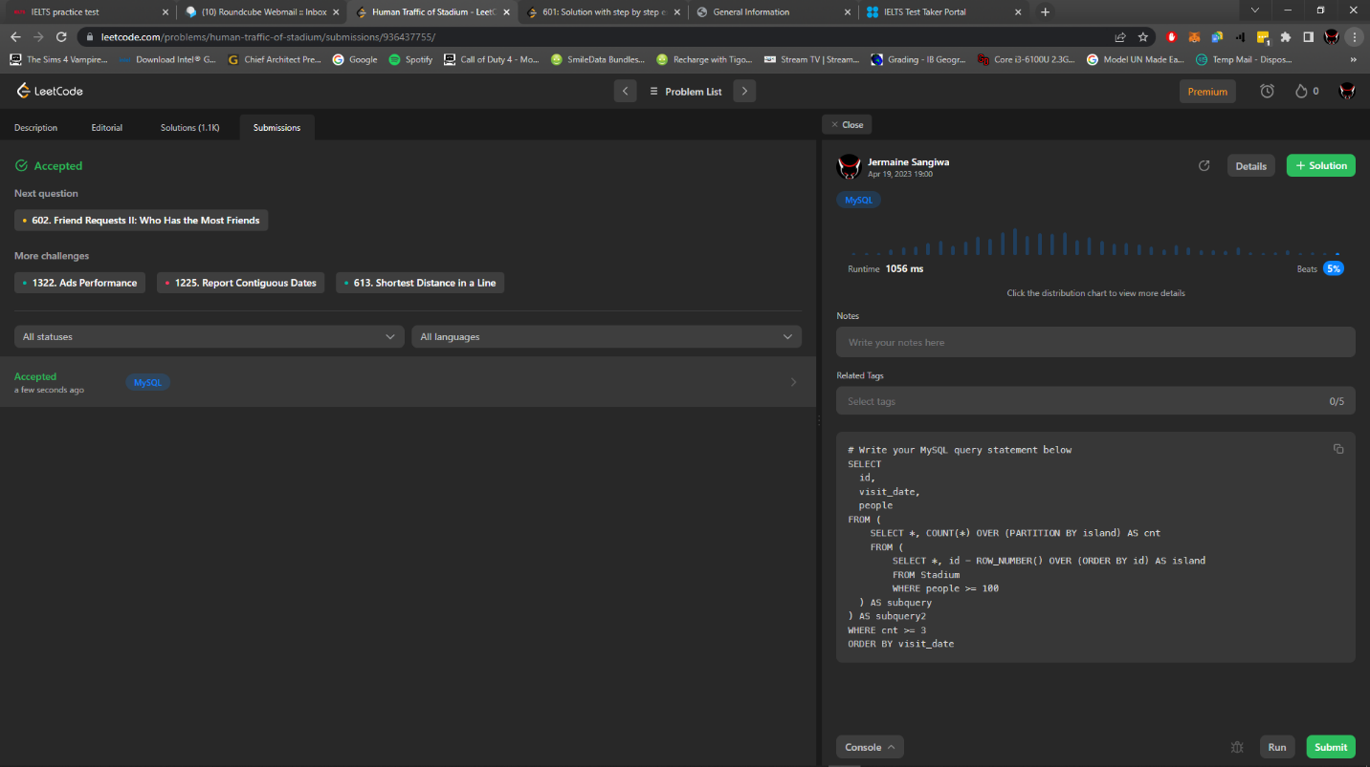

# QUESTION 2

Write an SQL query to find the ids of products that are both low fat and recyclable.

Return the result table in any order.

